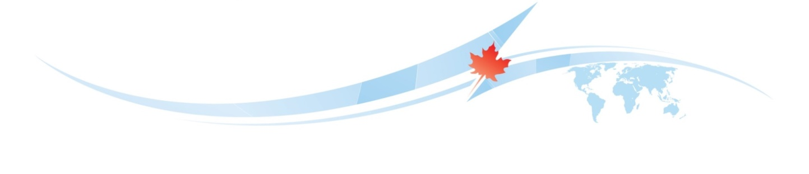

DOING BUSINESS
WITH C A N A D A
DATE:  June 9, 2017  11:30-14:45  (PL-EN simultaneous interpretation) | VENUE:  Office of the Marshal  of the Pomorskie Voivodeship  Okragła Room  Okopowa Street 21/27  80-810 Gdańsk

11:30 Registration of Participants
Moderator: Adam Mikołajczyk, Department of Economic Development, Office of the Marshal of the Pomorskie Voivodeship

12:00 Welcome remarks – Wiesław Byczkowski, the Deputy Marshal of the Pomorskie Voivodeship

12:15 Canada: Economic overview, our bilateral relationship with Poland and the Canada-EU Comprehensive Economic and Trade Agreement (CETA) – Nicolas Lepage, Senior Trade Commissioner, Embassy of Canada, Warsaw

12:45 Doing Business with Canada: legal aspects – Attorney Saad Syed, Barrister and Solicitor (Ontario, Canada)

13:05 Cultural aspects of doing business with Canada – Eileen Gricuk, Executive Director, Polish-Canada Chamber of Commerce (PCCC)

13:25 Overview of Canadian Immigration and Employment Programs – James Tieman, First Secretary (Immigration), Immigration, Refuges and Citizenship Canada, Embassy of Canada, Warsaw

13:45 Logistic consideration for exporting to Canada – Katarzyna Wesołowska, Raben Logistics Polska Sea & Air

14:05 Pomorskie’s Export Broker – Complex export support system in Pomorskie region. Aleksandra Harasiuk, Export Broker, Pomeranian Development Agency

14:25 Questions & Answers Period and Closing remarks

14:45 Coffee & Networking


